2024 Summer Games

Directions Book

Directions to Fort Jackson

We are being directed through Gate 2. This is the Forest Drive Entrance.

From the Upstate:
(Greenville/ Anderson: Follow I-385 South to I-26 towards Columbia)
Continue on I-26 East all the way into Columbia, merging onto I-126 towards Elmwood Ave. Follow Elmwood into Columbia and continue until you hit Bull Street. Turn RIGHT onto Bull Street. In 0.5 miles, turn LEFT onto Taylor Street. Continue straight for 0.9 miles and Taylor Street will become Forest Drive. Continue 4.3 miles and you will arrive at Ft Jackson (Gate 2) straight ahead.

From the Low Country:
Take I-26 to Columbia. Continue to EXIT 116 for I-77N towards Charlotte. Take EXIT 12 for Strom Thurmond Blvd. Keep RIGHT off the ramp and you’ll enter Ft Jackson at Gate 2.

From Myrtle Beach/ Florence, etc.:
Take I-20 WEST to Columbia.
Take Exit 76A/ I-77S. Get onto I-77S towards Charleston.
Continue on I-77 South until exit 12 for Ft Jackson. At the end of the ramp, take a LEFT onto Forest Drive. Continue straight as Ft Jackson (Gate 2) will be ahead of you.

From Aiken/ Columbia:
Take I-20 to Exit 76/ I-77. Get onto I-77 towards Charleston. Continue on I-77 South until exit 12 for Ft Jackson. At the end of the ramp, take a LEFT onto Forest Drive. Continue straight as Ft Jackson (Gate 2) will be ahead of you.

*From Gate #2 to the barracks at the 2-60th:
From Gate #2, continue to the second light and make a LEFT onto Jackson Blvd. You will see the 2-60th will be on the RIGHT. Follow the signs to the drop-off area. You can park in the small parking lot on the left across from battalion OR you can take the next right and go around the back of the battalion where there are larger parking lots and enter building form the back.

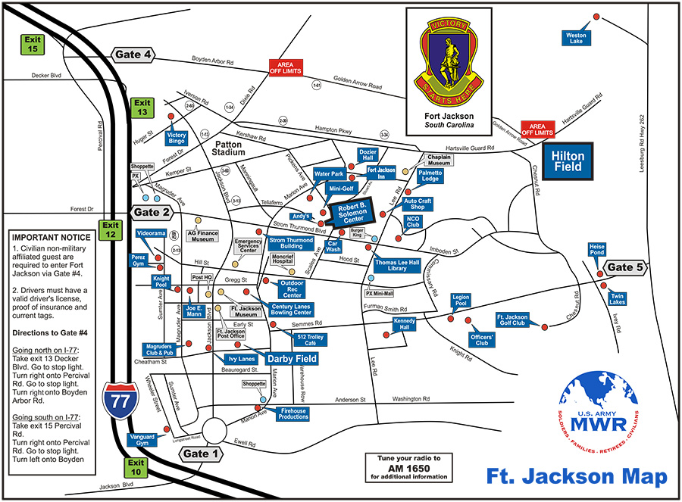
2-60th
SPRC Gym

From 2-60th to Solomon Center (Opening & Closing Ceremonies):
From the 2-60th take a LEFT onto Strom Thurmond Blvd and at the light turn LEFT on Marion Ave. The Solomon Center will be located on the RIGHT.

From 2-60th to Ft Jackson Inn (7550 Benning Road: Special Housing):
From the 2-60th, turn LEFT on to Strom Thurmond Blvd followed by a LEFT on Marion Ave. You must make a slight RIGHT onto Benning Rd. You will see the Ft Jackson Inn ahead.

From 2-60th to Knight Pool (Aquatics Facility):
From Jackson Blvd, turn LEFT at the light onto Strom Thurmond Blvd. Continue back to the main gate and turn LEFT at the light onto Magruder Ave. Follow Magruder Ave until you see that the pool facility is on your immediate right. Some parking is to your left (directly across the street from the pool). Extra parking is in the rear of the building.

From 2-60th to Century Lanes (Bowling Facility):
From Jackson Blvd, turn LEFT at the light onto Strom Thurmond Blvd. Continue back towards the main gate and turn LEFT at the light onto Magruder Ave. Follow Magruder Ave until the intersection of Magruder and Gregg Street. Turn left onto Gregg Street. The bowling facility is on your right in a few hundred feet. 4464 Gregg St, Columbia, SC 29207.

From 2-60th to Hilton Field (Softball):
From Jackson Blvd, turn LEFT at the light onto Strom Thurmond Blvd. Follow the blue line and turn LEFT onto Lee Rd. Follow Lee Rd. until the end and make a RIGHT onto Hampton Pkwy. Hilton Field will be ahead on your RIGHT. The blue line will lead you there.

From 2-60th to the 3-69 PT Field (Bocce):
From the 2-60th, continue straight on Jackson Blvd. Destination will be about a mile down on the left. The 3-69 field is located at the intersection of Jackson Blvd and Anderson St.

From 2-60th to SPRC Gym (Powerlifting Facility):
From Jackson Blvd, turn RIGHT and continue straight to the intersection of Huger St and Jackson Blvd. Facility will be on the LEFT and parking is behind the building.

From the 2-60th to Blythewood High School (Track and Field):
Exit out of Gate #2. Once out of the gate, get on I-77N towards Charlotte. Follow for 14.4 miles. Take EXIT 24 for US-21 toward Blythewood. Turn RIGHT onto US-21 N/Wilson Blvd and continue for 2.5 miles. Blythewood High School will be on your LEFT.

To All Star Gymnastics Center

From the 2-60th
Exit out of Gate #2. Once out of the gate, take ramp right onto I-77 North towards Charlotte.
Take Exit 16, putting you on I-20 West towards Augusta. You will stay on I-20 until you get to I-26 interchange.
Then Take Exit 64-B, putting you on I-26 West towards Spartanburg.
Take Exit 104/ Piney Grove Rd. Turn right from ramp at the light onto Piney Grove Rd.
Get into the left-hand lane.
Turn left at the next traffic light onto Fernandina Road; you will see a gas station on the corner and a Days Inn on the left as you make the turn.
Follow on around, passing Greens and Northern Tools on your right. You will see I-26 on the left as this is the frontage road.
The entrance to the parking lot for All Star Gymnastics is directly on the right as you make the curve. You will see a large white sign listing multiple businesses.
If you make it to the gym and the uniform store on the right, you have gone too far.
Turn right into the parking lot curving around a large white warehouse.
All Star Gymnastics is the third glass door as you come around with the building on the right.
Fernandina Rd # D, Columbia, SC 29212
From the Upstate
From I-26 East towards Columbia, take exit 104/Piney Grove Rd. Turn left off exit ramp onto Piney Grove, crossing back over the interstate. Turn left at traffic light onto Fernandina Road; you will see a gas station on the corner and a Days Inn on the left as you make the turn.
Follow on around, passing Greens and Northern Tools on your right. You will see I-26 on the left as this is the frontage road.
The entrance to the parking lot for All Star Gymnastics is directly on the right as you make the curve. You will see a large white sign listing multiple businesses.
If you make it to the gym and the uniform store on the right, you have gone too far.
Turn right into the parking lot curving around a large white warehouse.
All Star Gymnastics is the third glass door as you come around with the building on the right.
Fernandina Rd # D, Columbia, SC 29212

From Florence
Take I-20 WEST from Florence to Columbia. You will stay on I-20 until you get to I-26 interchange. Then Take Exit 64-B, putting you on I-26 West towards Spartanburg.
Take Exit 104/ Piney Grove Rd. Turn right from ramp at the light onto Piney Grove Rd.
Get into the left-hand lane.
Turn left at the next traffic light onto Fernandina Road; you will see a gas station on the corner and a Days Inn on the left as you make the turn.
Follow on around, passing Greens and Northern Tools on your right. You will see I-26 on the left as this is the frontage road.
The entrance to the parking lot for All Star Gymnastics is directly on the right as you make the curve. You will see a large white sign listing multiple businesses.
If you make it to the gym and the uniform store on the right, you have gone too far.
Turn right into the parking lot curving around a large white warehouse. All Star Gymnastics is the third glass door as you come around with the building on the right.
Fernandina Rd # D, Columbia, SC 29212

From Charleston
Take I-26 WEST to Columbia. You will pass the I-20 interchange.
Take Exit 104/ Piney Grove Rd. Turn right from ramp at the light onto Piney Grove Rd.
Get into the left-hand lane.
Turn left at the next traffic light onto Fernandina Road; you will see a gas station on the corner and a Days Inn on the left as you make the turn.
Follow on around, passing Greens and Northern Tools on your right. You will see I-26 on the left as this is the frontage road.
The entrance to the parking lot for All Star Gymnastics is directly on the right as you make the curve. You will see a large white sign listing multiple businesses.
If you make it to the gym and the uniform store on the right, you have gone too far.
Turn right into the parking lot curving around a large white warehouse.
All Star Gymnastics is the third glass door as you come around with the building on the right.
Fernandina Rd # D, Columbia, SC 29212

To Blythewood High School

From the 2-60th
Exit out of Gate #2. Once out of the gate, take ramp right onto I-77 North towards Charlotte.
Merge onto I-77 N ramp to Charlotte.
Then Take Exit 24 for US-21 N toward Blythewood.
Keep right at the fork, follow signs for US-21 N/Wilson Blvd/Blythewood.
Merge onto US-21 N/Wilson Blvd.
Follow for 2.4 miles. Turn left at the Blythewood High School entrance.
Follow directional signs to track.
10901 Wilson Blvd, Blythewood, SC 29016
From the Upstate
From I-85 N take exit72 for US-176 E/I-585 S toward Spartanburg.
Keep right at the fork, follow signs for Spartanburg/I-585 S/US-176 E. Keep right at the fork.
Follow for 3 miles and then use any lane to turn sharply right to stay on I-585 S.
Follow for 18 miles and then turn left onto Forest St/State Rd S-44-12
Continue for 1 mile and turn right onto SC-9 S/S Main St. Keep left.
Continue for 2.5 miles and turn left onto SC-49 N/SC-9 S
Follow for 14 miles and turn right onto US-321 S/J A Cochran Bypass. Follow for 2.5 miles.
Turn right onto US-321 S. In half a mile turn right onto the I-77 S ramp to Columbia and merge.
Take exit 27 toward Blythewood Rd/State Rd S-40-59 and keep left at the fork.
Pass the Wendy’s and turn left onto Blythewood Rd/State Rd S-40-59. Follow for half a mile.
Turn right at the Blythewood High School entrance.
Follow directional signs to track.
10901 Wilson Blvd, Blythewood, SC 29016

From Florence
Get on I-95 S from State Rd S-21-12 and US-52 N/W Lucas St (3.6 mi).
Head east toward E Cheves St/State Rd S-21-92 and turn right to stay on E Cheves St/State Rd S-21-12.
Turn right onto E Cheves St/State Rd S-21-92.
Turn left at the 1st cross street onto S Church St/State Rd S-21-12 and continue.
Use the right 2 lanes to merge onto US-52 N/W Lucas St.
Slight right to merge onto I-95 S toward Savannah.
Take I-20 W to US-21 N/Wilson Blvd in Richland County. Take exit 24 from I-77 N.
Continue on US-21 N/Wilson Blvd to your destination in Blythewood.
Merge onto US-21 N/Wilson Blvd.
Turn left at the Blythewood High School entrance.
Follow directional signs to track.
10901 Wilson Blvd, Blythewood, SC 29016

From Charleston
Get on I-26 W and continue on I-26 W to Richland County.
Follow for 103 miles and take exit 116 for I-77 toward Charlotte.
Continue onto I-77 N and take exit 24 to merge onto US-21 N/Wilson Blvd toward Blythewood.
Continue on US-21 N/Wilson Blvd to your destination in Blythewood
Merge onto US-21 N/Wilson Blvd
Follow for 2.4 miles. Turn left at the Blythewood High School entrance.
Follow directional signs to track.
10901 Wilson Blvd, Blythewood, SC 29016

