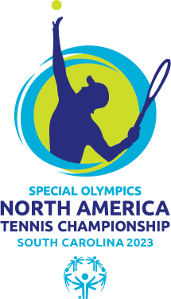

Family Registration/Information

Families of our delegation members can register to receive Meal Plan benefits to eat lunch with and/or attend the Dinner Dance with their family member. Please review details below.
- Meal Plan A $30/per person
  - Lunch is provided Thursday, Friday, and Saturday of the tournament. Lunch is sandwich, chips, and dessert (cookie or small dessert item)
  - Varied types of sandwiches are offered each day
- Meal Plan B $70 per person
  - Lunch is provided Thursday, Friday, and Saturday of the tournament. Lunch is sandwich, chips, and dessert (cookie or small dessert item)
  - Varied types of sandwiches are offered each day
  - Dinner is provided at the Dinner Dance celebration Friday evening

Registration deadline for family members is Wednesday, Oct 4.

Lunch will be served each day from the Porch of the Van Der Meer Tennis Center for Tennis. Family members are invited to come and give the number of lunches registered for and name registered under.
Lunch will be served each day form the Covered Awning of the Palmetto Dunes Tennis and Pickleball Center for Pickleball. Family members are invited to come and give the number of lunches registered for and name registered under.

The Dinner Dance is located at Hilton Head Beach and Tennis.
Hilton Head Beach and Tennis
40 Folly Field Rd
Hilton Head Island, SC 29928

Payment can be made:
- Check mailed to
SONA Tennis and Pickleball Championship
Special Olympics South Carolina
109 Oak Park Dr
Irmo, SC 29063
- VENMO
  - Make note in memo “SONA Tennis and Pickleball Family Registration”
- Contact Anthony Buzzetti, Director of Community Outreach and Family Contact for SONA Tennis and Pickleball Championship, to make Credit Card Payment @ 803-404-5516.

For any further questions concerning Family Registration/Information please contact Anthony Buzzetti 803-404-5516 or abuzzetti@so-sc.org.

